July 30, 2014

Ms. Esther Levy
Acting Director, Child and Youth At-Risk Branch
Policy Development and Program Design Division
Ministry of Children and Youth Services
Children and Youth Development Branch
Strategic Policy and Planning Division
3rd Floor 101 Bloor St. West
Toronto, ON M5S 2Z7

Re: Preschool Speech and Language Program Resource: “Can Your Baby Hear?”

Dear Ms. Levy:

This letter is to comment on the resource used in the Preschool Speech and Language program entitled “Can Your Baby Hear?” We are members of the Ontario Society for Nutrition Professionals in Public Health (OSNPPH). OSNPPH is the official voice of public health nutrition professionals in Ontario and represents Registered Dietitians working in the 36 public health units in Ontario.

We would like to bring to your attention our concerns about three examples within the above resource along with suggested changes. These examples are:

- Under section By 30 months: “Your child uses some adult grammar - uses the example of two cookies” – The use of “two cookies” normalizes foods that do not contribute to overall health. We would suggest using a non-food reference such as “two trees” or “two dogs”, or use more nutritious food items such as “two apples” or “two carrots.”

- Under section By 30 months: “recognizes familiar logos and signs – McDonalds golden arches, stop sign” – The reference to McDonalds golden arches again normalizes food establishments that offer unhealthy foods and aggressively market and advertise to children. We would suggest using other non-food symbols such as traffic lights.

- Under section Toddlers like it when you: “Use real words instead of baby talk – “give me” instead of “ta ta” or “bottle” instead of “baba.” The reference to the word bottle is not supportive of the Baby-Friendly Initiative (BFI) and does not support national feeding guidelines that promote the use of an open cup for toddlers to reduce risk of

obesity and tooth decay, rather than sippy cups or bottles which are currently used in your resource. We would suggest using a different example such as “blanket” instead of the term “blankie” or “diaper” instead of the term “nappie.”

Thank you for taking the time to consider our concerns. We welcome further dialogue on this or other resources that you might be developing. If you have questions or require clarification please do not hesitate to contact Kim McGibbon, member of the OSNPPH Family Health Nutrition Advisory Group, by email at kim.mcgibbon@york.ca.

Sincerely,

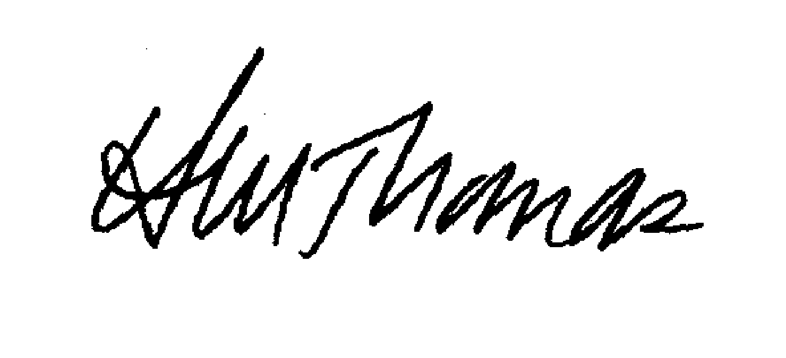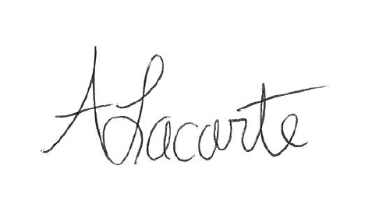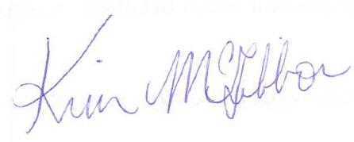

Heather Thomas, PhD, RD  Past Chair, OSNPPH  Public Health Dietitian | Alexandra Lacarte, RD  Chair, Family Health Nutrition Advisory Group, OSNPPH  Public Health Dietitian | Kim McGibbon, MScCH, RD  Member, Family Health Nutrition Advisory Group, OSNPPH  Public Health Nutritionist

