July 31, 2013

The Honorable Deb Matthews  Minister of Health and Long Term Care,  Deputy Premier  Ministry of Health and Long-Term Care  10th Floor, Hepburn Block  80 Grosvenor Street  Toronto, Ontario M7A 2C4 | The Honorable Teresa Piruzza  Ministry of Children and Youth Services  ServiceOntario INFOline  M-1B114, Macdonald Block  900 Bay Street  Toronto ON M7A 1N3

Re: Healthy Kids Panel Report: No Time to Wait

Dear Minister Matthews and Minister Piruzza:

The Ontario Society of Nutrition Professionals in Public Health (OSNPPH) sent congratulations to your office after the Healthy Kids Panel (HKP) report, No Time to Wait, was released. Since then, our members have studied the report thoroughly. We are pleased to share with you how our work in public health nutrition across the province relates to the report’s recommendations.

OSNPPH is the independent and official voice of over 200 Registered Dietitians (RDs) working in Ontario’s public health system. OSNPPH provides leadership in public health nutrition by promoting and supporting member collaboration to improve the health of Ontario residents. Our work is consistent with the Ministry of Health and Long-Term Care’s 2008 Ontario Public Health Standards, the Ministry of Children and Youth Services’ Student Nutrition Program Guidelines and the Ministry of Education’s Foundations for a Healthy School.

We agree with strong support of the HKP report expressed by a number of other expert organizations. The Association of Local Public Health Agencies’ (alPHa) stated in its letter to you dated March 21, 2013, “public health is already carrying out key roles” in many of the areas addressed by the proposed strategy. Specifically, Registered Dietitians working in Ontario public health units have the required critical skills, knowledge, and mandate to focus on healthy weights and obesity prevention. OSNPPH encourages leveraging the specialized expertise of these RDs. Through optimal resourcing, support and investment, our members can both fulfill mandated Ontario Public Health Standards as well as participate actively or in an advisory role across most of the HKP recommendations. Enhancing our capacity will be a key means to increase momentum and impact, allowing RDs to make even greater contributions to development and implementation of evidence-informed strategies at local and provincial levels.

Unfortunately, the lack of reference in the report to public health Registered Dietitians is a major gap.

As a prime example, the expertise of Registered Dietitians in public health could be optimized towards the building of a “comprehensive surveillance system built to monitor progress and ensure accountability,” as highlighted in the report’s recommendations. Identification and cross-sector integration of appropriate measurement tools for childhood obesity requires a comprehensive approach at the population health level. Echoing a recent report on measuring child health from Public Health Ontario ¹, we urge recognition and consideration that the risk factors, diseases and disorders, and health determinants for children differ from those for adults. OSNPPH members have collaborated with Dr. Gail McVey in her applied research on adult influencers of weight bias. Consequently, we caution that the collection of weight/Body Mass Index (BMI) data on children as the main measure of progress, which lacks appropriate and ethical safeguards and risks unintended consequences (such as poor mental health, weight stigma, and eating disorders). We strongly recommend reframing the approach, similar to Quebec’s and

British Columbia’s strategies, so that the focus is moved away from BMI and toward better mental health promotion.

We recommend the Sudbury & District Health Unit’s proposed Causal Model (Appendix A) as the guide for development and/or use of indicators and data sources. As well, we encourage your Ministries to support the Public Health Ontario Locally Driven Collaborative Project proposal “Beyond BMI: Developing a strategy for collecting data on childhood healthy weights” (Appendix B). Additionally, NutriSTEP©, an existing parent education program, includes validated and reliable data collection tools. The program and its monitoring tools could be integrated as an accountability agreement indicator for local health unit implementation (see Appendix C for more details).

Toward achieving the above, OSNPPH is eager to participate in advancing the work of the Inter-Ministerial Committee. We encourage you to extend the invitation to leverage our members’ collective expertise to assist in bringing the recommendations of the report to fruition. Please contact me to discuss this opportunity.

Sincerely,
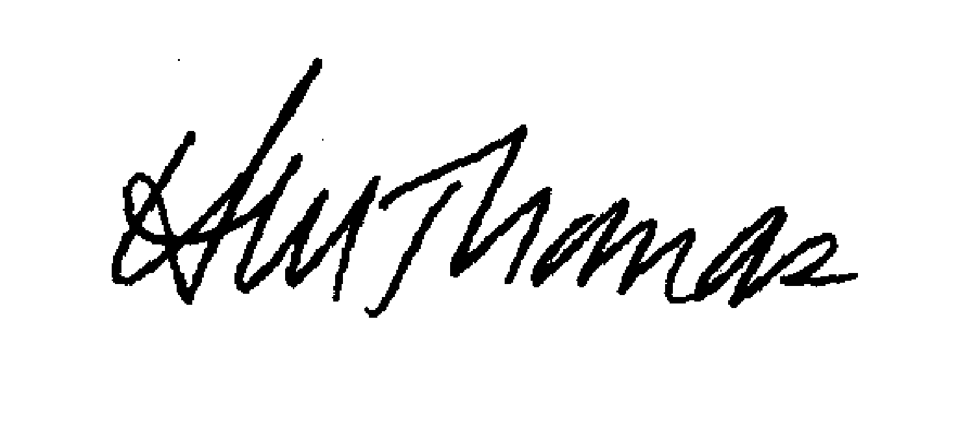
Heather Thomas, PhD, RD
Co-Chair, OSNPPH
Chair, OSNPPH Advocacy Committee
(519) 663-5317 ext 2222
heather.thomas@mlhu.on.ca

CC Dr. Arlene King, Chief Medical Officer of Health
Ms. Kate Manson-Smith, ADM Health Promotion, Ministry of Health and Long-Term Care
Ms. Suzanne McGurn, ADM Health Human Resources Strategy, Ministry of Health and Long-Term Care
Ms. Olha Dobush, Ministry of Health and Long-Term Care
Ms. Laura Pisko, Ministry of Health and Long-Term Care
Dr. Aryeh Gitterman, ADM Policy Development and Program Design, Ministry of Child and Youth Services
Mr. Robert Burkholder, ADM Service Delivery, Ministry of Child and Youth Services
Dr. Heather Manson, Public Health Ontario
Ms. Linda Stewart, Association of Local Public Health Agencies
Mr. Cameron McDermaid, Association of Public Health Epidemiologists in Ontario
Ms. Leslie Whittington-Carter, Dietitians of Canada

Enclosures:

Appendix A: Causal Model, Sudbury & District Health Unit
Appendix B: Beyond BMI: Developing a strategy for collecting data on childhood healthy weights
Appendix C: NutriSTEP©

References:

¹ Public Health Ontario (2013). Measuring the health of infants, children and youth for public health in Ontario: Indicators, gaps and recommendations for moving forward.

